MAME File Manager
User Guide

Author phweda
Reviewer coccola


0.85 Release

Table of Contents
Introduction 1
Prerequisites 2
Installing 3
First Run 4
User Interface 6
List Builder 9
Resources 11
Command Line Options 12
Mouse Actions 13
Hot Keys 14
Menus 15
Popup Menu 17
DATs 18
Troubleshooting 19
Help 20
Caution 21
Advanced Usage 22
What's New 23
MAME XML 24
Appendix A – MFM <version>.zip 25
Appendix B – Machine Information 26
Appendix C – Editing startup scripts 27
Appendix D – Resources & Logic 28
Appendix E – Fatal Errors 30
Appendix F – Add-on Look and Feels 31
Appendix G – MAME Installation 32
Appendix H – MAME Data Sets 33
Why Two Sets? 33
Location 33
Appendix I – Glossary 34
Appendix J – Data Set Torrent 35
Appendix K – Source Code 36

Introduction

MAME File Manager (MFM) is a desktop application for creating lists of Games and Systems, and extracting sets of MAME ROMs, CHDs, and Extras to another location from complete or larger sets. As of May 2017 the total of MAME resources is 2.3 TB+! MFM helps you create smaller sets.

Its primary goals are:
- Display all available information for each Machine
- Filter machines to create lists
- Create Playsets from lists

The primary focus of MFM is machines that are runnable. In conjunction with the 0.85 release we will begin to share both full and runnable only Data Sets.

MFM does not audit or manage ROMs/CHDs/Extras in any way except for the intended copying a subset of runnable machines to a different location. It does not validate those files. Use a ROM Manager (such as Clrmamepro or RomVault) to validate/fix your sets.

MFM will run MAME for you if you have your MAME properly setup and configured. This is a limited feature providing basics such as running a machine or running and recording a machine. MFM does not seek to be a full MAME frontend.

Prerequisites

Java 8 or higher installed.

At least one set of: MAME ROMs, CHDs, Software List ROMs or Software List CHDs.

MAME – some features of MFM require the MAME executable or additionally MAME preconfigured to run Machines. (see MAME Installation)

Theoretically MFM will run on any OS with Java 8 JVM
Tested Operating Systems:
- Windows 7 & 10
- Linux Ubuntu 16.10
- Mac OS X El Capitan

RAM Memory
Minimum System RAM for the JVM (Java Virtual Machine) will vary based on many factors. For simple 'out of the box' usage you need at least 1 GB although 2 GB is recommended. Parsing MAME (see Advanced Usage) requires 4+ GB. With Data Sets the most recent MAME versions, 180+, the required RAM to run the ALL set is 3+ GB.
For 32-bit Java your maximum RAM for the JVM is approximately 1280 to 1536 MB.

Screen Size
1280 x 1024 is the smallest screen size that MFM supports. However note that if you use the large or very large fonts some things will not show completely at that resolution.
1600 x 1024 or larger is recommended.

Installing

File MFM <version>.zip

Unzip all contents into a folder. Recommended is to give MFM its own folder.

Get Data Sets
Download one or more Data Sets from the site you obtained MFM. These are placed into <MFM Root>/Data folder. MFM automatically searches that folder.

If Java system variables are set in your OS (standard Java x64 installation) MFM is ready to run. Exception is if you are on 32-bit Java, you must edit the startup script.

Use the MFM.bat or MFM.sh file provided. These will run without editing. If you do not have Java system variables set you will need to edit your .bat or .sh to point to the Java executable. See editing startup scripts.

From Previous MFM
If you have a previous MFM you can copy over your playlists.

Copy file MFM_Playlists.xml from your old MFM to your new <MFM Root>/Settings folder.

First Run
A settings windows will open. Image contains example entries as if filled out by you. Left-click twice on the edit box to launch the File Chooser. Any path you can traverse in the File Chooser can be used.

- Playset directory is where MFM will copy resources to. Simplest setup is to use your MAME directory.
- MAME Executable is where the installed binary of MAME is (mame64.exe), NOT the installation binary (e.g. mame0180b_64bit.exe).
- MAME ROMs NON-MERGED checkbox to differentiate Split and Merged sets from Non-Merged. Check if you have Non-Merged ROM set. If you have a Split or Merged set and check this your set will be missing some or all required ROMs. If unchecked and you have a Non-Merged set unneeded resources are copied.

If you have more than one Data Set you will then be prompted to select a Data Set.

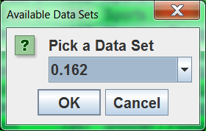
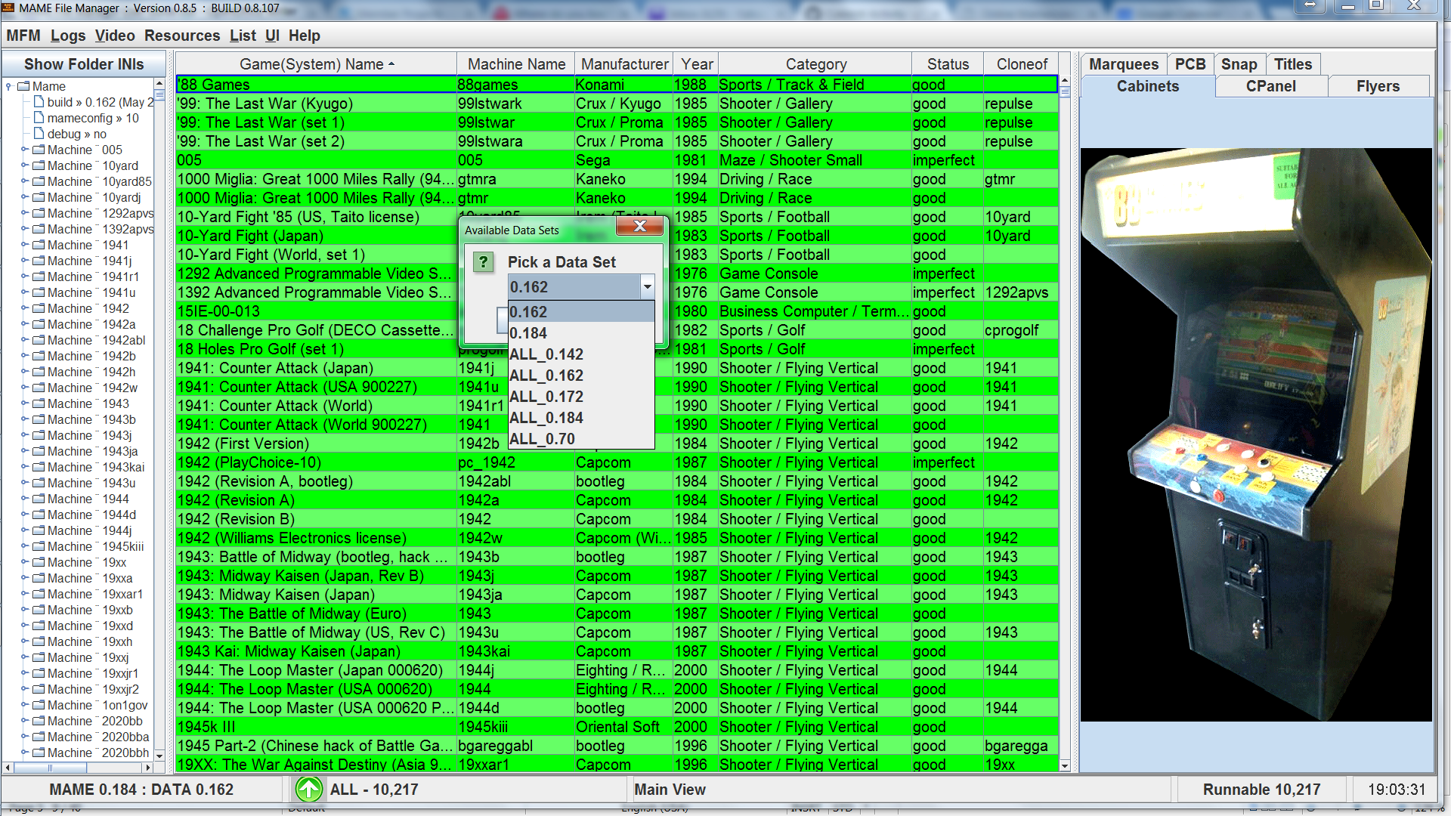

User Interface

There are two basic modes: Full and List Only.

Full mode, if you have .inis you will get the left panel where you can view them in a tree.
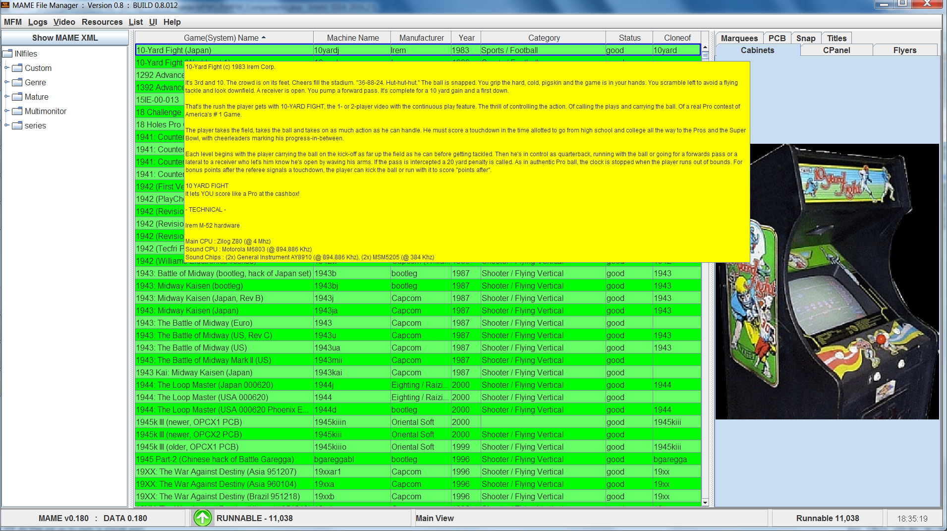

Otherwise you get similar with MAME XML in the left hand panel. All else is identical.

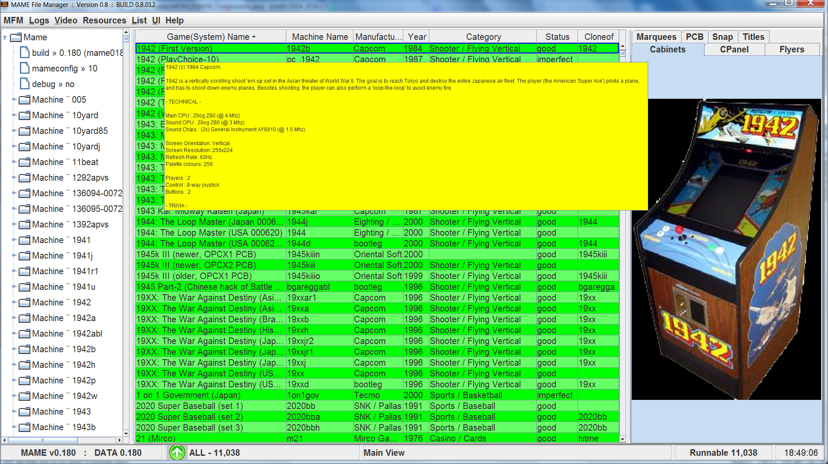

The List Only mode can be activated via switch -list (see Command Line Options).

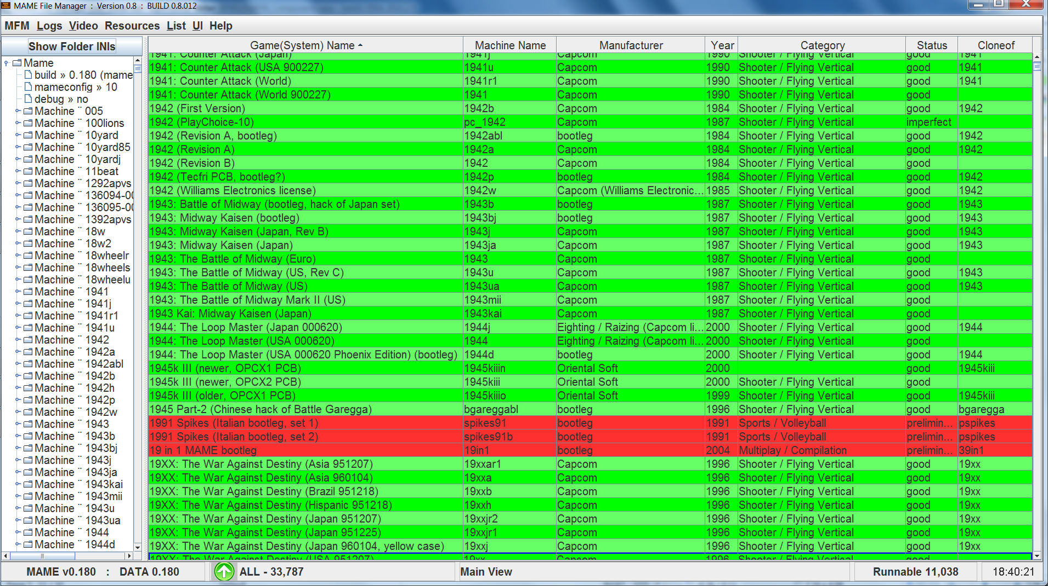
When you load a data set or parse MAME for all machines (-all) those marked as preliminary, not runnable, will be highlighted in red. Preliminary machines only appear in the: All, Arcade, BIOS, Devices, Systems(MESS), and Languages lists.

List Builder

Categories – if no categories are selected MFM does not filter categories
Controls – if no controls are selected MFM does not filter controls
Make your selections, enter a List Name, and select Create List. If list generated has one or more entries it will be created and displayed in the main view.
Save List to File – Saves selected list to a text file in the <MFM Root>/Lists directory. File name is <List Name><Data Version>.txt
Import List – Imports list from a text file
Copy Resources – Copies ROMs, CHDs, Extras from your full sets to your Playset directory for selected list.

Game Picker – disabled legacy function
Diff Lists – when there are two text files with lists of games (probably generated by the Save List to File button), the Diff Lists button will compare these two files and show which games are unique to each file.

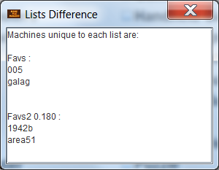

Resources

Scanning
When MFM scans, Resources → Scan Resources, it catalogs all of the files in the roots of your ROMs, CHDs, and Extras sets. Every time you update or change your sets you must rescan. This data is stored in <MFM Root>/Settings/Resources_cache.ser

Copying
Resources → Copy Resources MFM looks up resources in the Resources_cache.ser for each machine in the selected list. It copies them to the corresponding folder in your playset directory.

It is important to keep your sets 'clean'. MFM utilizes naming conventions to identify and copy resources. ROMs and CHDs by filename, and Extras by zip or folder name plus filename. If there are naming collisions in your sets, duplicate names, MFM resource copying behavior is not guaranteed.

Command Line Options

-all Include non runnable machines in lists (only applies when you parse MAME)
-list list only view
-d debug logging
-m memory usage logging
-s system out development logging – writes to command shell – some of these also go to the standard debug log

Examples see below

Mouse Actions

Double Click
- In the List: will run that Machine (if your MAME is configured)
- Over an Extras image: will open that image file from your OS

Hover
- Over the Game(System) Name column: will open a tool tip with the top of the history entry for that machine see above

Left Click – ini Folder view only
- If machine highlighted in the Folder tree exists in the open list that list will scroll to it

Right Click
- Over MAME tree: will copy the value displayed at that location
- Over the list: will open a popup menu for that machine

Hot Keys
Key | Function – for selected Machine
ENTER | Run the selected Machine
F1 | Show History
F2 | Show Manual
F3 | Show Info
F4 | Record Game to INP
F5 | Playback to AVI
F6 | Playback Game
F7 | Play Game to AVI
F8 | Play Video
F9 | Edit AVI
F10 | unassigned
F11 | Crop AVI
F12 | Convert Videos to MP4
CTRL c | Copy – copies selected Machine information
CTRL o | Opens file chooser in the MFM List directory to open selected file
CTRL x | Show XML for selected Machine
CTRL z | Zip MFM logs
CTRL → | Go to next list
CTRL ← | Go to previous list
ALT → | Go to next My List
ALT ← | Go to previous My List
a | Switch to the ALL list
c | Switch to the CLONE list
h | Switch to the HORIZONTAL list
n | Switch to the NOCLONE list
r | Switch to the RUNNABLE list
s | Switch to the SYSTEMS(MESS) list
v | Switch to the VERTICAL
CTRL a | Switch to the ARCADE list
CTRL n | Switch to the NOIMPERFECT list
CTRL r | Switch to the RASTER list
CTRL s | Switch to the SIMULTANEOUS list
CTRL v | Switch to the VECTOR list

Menus

- MFM
  - Open File – Opens a file chooser window in the MFM Lists folder. File chosen will be opened from the OS (if a file association exists).
  - Settings – Opens the MFM settings window
  - Load Data Set – User selects MAME Data Set by version (if more than one is present)
  - Parse MAME – User initiated data set creation. Parses the MAME executable in settings.
  - Exit – Closes MFM
- Logs
  - Log – Opens the MFM log in your OS's default Text editor
  - MAME_OUTPUT – Opens log of MAME command shell output. (only if you ran MAME from MFM)
  - Error Log - Opens the MFM error log in your OS's default Text editor
If you run with -d or -s debug flags you will also get these three menus
  - Zip Logs – zips up your MFM logs
  - Paste errors to Pastie – pastes last 100 lines of the error log to pastie.org
  - DUMP WAYS Controls – Saves this information to file to support coding filters
  - Clean Logs – Deletes any MFM logs older than 48 hours
- Video
  - Vdub – legacy function to support video project requires VirtualDub
  - Ffmpeg – legacy function to support video project requires ffmpeg
- Resources
  - Scan Resources – Scans the resource roots in your MFM settings and stores the file information to support copying resources
  - Copy Resources – Copies all available resources for the Machines in the selected list to the Playset directory
  - Save Resources to File – Creates a text file with a list of the resources found by MFM for this list

- List
  - List Builder
    - Previous – Opens the state of List Builder when last used
    - New – Opens fresh corresponds to the All list
    - (MFM built in lists) – Opens List Builder with setting to produce this MFM built in list
  - My Lists
    - (Lists you have created or imported)
  - MFM Lists
    - (All built in MFM lists)
  - Import List – creates list from a file
  - Remove List – deletes this list from MFM
  - Save List to File – creates text file with this list's machines
  - Save List Data – creates a CSV file with a subset of Machine data
  - Create List DAT – creates DAT file
- UI
  - Font Size – changes the display font size
    - Very Large
    - Large
    - Normal
  - Look & Feel – synonymous with skins; changes the look of the MFM GUI
    - Various depending on your OS and Java installation.
- Help
  - MFM User Guide – this guide
  - About
  - MFM Copyright
  - GNU Copyright

Popup Menu
- Add to List : Adds this machine to list you select. If you select -NEW- you can enter a new list name which will be created with this machine as its entry.
- Remove from List : Remove this machine from list you select
↓ If you have MAME configured properly; otherwise these will fail.
- Record : Runs machine in MAME and records to .inp file
- Play Video : If a video file exists for this machine opens it from your OS
- VideoOps
  - Play & Record to AVI : Runs machine in MAME and records to AVI file (configured snaps directory)
  - Playback to AVI : If .inp exists for this machine plays it back in MAME while recording to AVI file
  - Edit Video : If .avi file exists for this machine and you have VirtualDub installed opens that file in VirtualDub
  - Crop AVI : If .avi file exists for this machine and you have ffmpeg installed will crop the avi to even numbers (some systems output unusual AVI frame sizes)
- Show History : Shows the full History for this machine
- Show Manual : If manual exists for this machine opens it from your OS
- Show Info : Show all the info available for this machine
- Show Machine Tree : Opens MAME XML for this machine
- Show Controls & Devices : Shows controls and devices for this machine
- GOTO cloneof : If parent machine is in this list scrolls to that parent machine
- Open Image : Opens currently displayed image from your OS
- Exit : Exits MFM

DATs

MFM produces DAT files for lists. The DAT produced is complete per Machine. Each entry contains all the required resources: BIOS, CHD, Devices, and ROMs. In the parlance of MAME it would be a Full Non-merged set. See Non-Merged.

Troubleshooting

- MFM does not run when I execute the .bat or .sh file.
  - Do you have Java 8 or higher installed? Goto a command shell and enter >java -version
You should get output like:
java version "1.8.0_112"
Java(TM) SE Runtime Environment (build 1.8.0_112-b15)
Java HotSpot(TM) 64-Bit Server VM (build 25.112-b15, mixed mode)
Solutions
If you do have Java installed try editing your .bat or .sh file to point directly (complete path) to the java.exe file
Otherwise install Java
  - Check for MFM logs in the <MFM Root>/Logs directory. You should find two logs for each attempt.
    - Contact us with logs available
    - If logs do not exist try to run the .bat or .sh from the command shell. In that file add the -d and -s flags
    - Save the command line output and contact us
- First run after inputting Settings you get the following dialog but do not want to Parse. Did you download Data Sets and place them in <MFM Root>/Data folder?
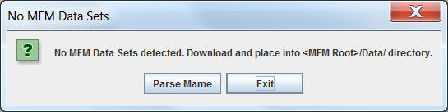
- MFM regularly hangs, stops responding, for 1 to 5+ seconds. JVM is pausing to free up memory
  - Run in List Only mode MFM flag -list : extracting/showing images uses a lot of memory
  - Increase the memory to run MFM

Help

If you are familiar with the site we are members of you can get on the forum thread for MFM.
Or you can join us on IRC. ForeverChat #MFM channel.

Caution

- Always close MFM in the application via MFM → Exit or the close X of the window.
  - MFM utilizes temporary files to display or open zipped resources. It will delete these on proper exit.
- Do not run MFM by double clicking the .jar file. If you do MFM may draw too much memory (RAM) and slow your system.
- MFM does not monitor your ROMs/CHDs/Extras sets. If you update or change them you must rescan resources before copying.
- When copying resources to your Playset directory MFM will, without warning, overwrite any files already there.
- NEVER try to edit settings files except the two noted in the next section Advanced Usage.

Advanced Usage

Following require some manual steps. In the future some of these will be automated.

- Controllers name mapping You can change the display names for controllers displayed in the List Builder. Goto <MFM Root>/Settings and open file MAME_Controllers.ini. You will see entries such as:
dial = Dial
doublejoy = 2 Joysticks
gambling = Gambling Buttons
DO NOT change values on the left. Values on the right after the = can be changed. Save your changes and restart MFM. Open List Builder → New you should see your controller names changed.
- Adding/changing Extras folders
MAME_folders.ini contains the list of folder/zip names MFM uses to search for and copy machine extras. You can add or change this list by editing that file. For example I do NOT want Artwork copied so I remove that line. Maybe you have an older Extras set and want folder cabdevs copied. Add a line cabdevs to the file.
Open <MFM Root>/Settings/MAME_folders.ini
- Parsing MAME
  - You must have MAME Extras if you want all data.
  - If you want updated category, version, language and players information you need to get most recent versions of these files:
    - catver.ini → Found at Progetto Snaps
    - Extras files
  - MFM → Parse MAME Parses the currently set MAME executable
  - If you have setup correctly you should see the following progress window
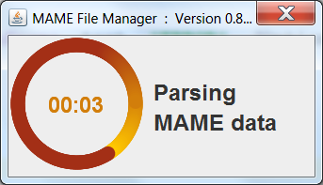
NOTE: Parsing is NOT bulletproof. Contact the author for Help.

What's New

0.85 Release
- Major addition is support for switching between data for multiple MAME versions
- Parsing and display of -listxml for all MAME versions beginning with 0.70 (first with -listxml) to present
- Parsing your MAME version triggered from the UI
- Added Devices as a built-in list
- Fix parsing bug for updated messinfo.dat (183 extras)

MAME XML

It is important to understand the context of the MAME -listxml output within the overall project. MAME's purpose is to preserve decades of software history. Outputting machine related data via XML is an add-on data dissemination feature provided to benefit MAME related tools, primarily Front Ends and ROM Managers. And of course MFM.
MAME XML Document structure is defined by a DTD. However that definition is not static. It changes over time as the MAME project evolves. Maintaining backward compatibility is NOT a requirement for the MAMEDev team. So any tool utilizing this output must adjust to these changes over time.
With the 0.85 release MFM supports the MAME XML for all versions beginning with 0.70 onward. However this does not mean “all the XML”. Where needed to support core MFM functionality, such as lists and DATs, MFM code is provided to port older information to the newer XML Document type.
MFM's code base for MAME objects is based on the MAME 180 DTD. This means that for the most recent MAME versions (175-185) the XML displayed and used by MFM is an exact representation. The further back the MAME version the greater the gaps in the XML displayed by MFM.

As of MAME 0.185 there have been 27 different DTDs for MAME XML.
70, 71, 85, 96, 102, 107, 115, 118, 124, 127, 132, 135, 136, 137, 139, 140, 142, 143, 144, 145, 146, 150, 153, 162, 173, 175, 184.
Where a simple Element rename occurred e.g. Game to Machine the translation by code is simple. But in MFM you will always see “Machine” in the displayed XML even for versions 161 or older where the actual XML has “Game”.

Appendix A – MFM <version>.zip

MFM<version>.zip contains:
- MFM.jar – the application
- MFM.bat – command file for Windows
- MFM.sh – shell file for Unix systems
- Folders
  - Category
    - ArcadeCategoryRoots.xml
    - CategoryListsMap.xml
    - CategoryRoots.xml
  - folders
    - catver.ini
    - languages.ini
    - nplayers.ini
  - Jars
    - swingx-all-1.6.4.jar
  - Lists
    - Favs.txt Phweda's favorites – use List → Import List to add to MFM
  - Settings
    - MAME_Controllers.ini Controllers naming mapping
    - MAME_folders.ini MAME extras folders list
- MAME File Manager User Guide.pdf

Appendix B – Machine Information

MFM utilizes multiple sources for information.

The MAME executable is the primary source of information. It is obtained by parsing the -listxml output. 0.85 release can provide XML output for MAME 0.70 or newer.

Progetto-SNAPS by AntoPISA provides the catver.ini and languages.ini files bundled and used by MFM. All Category, Version and Languages data in MFM are from these two files. Additionally a huge number of the MAME Extras resources come from this site.

MAME Extras contain information files which MFM parses. They are: history.dat, mameinfo.dat, mess.dat, sysinfo.dat, languages.ini, nplayers.ini

Appendix C – Editing startup scripts

Editing your .bat or .sh startup script
To reference Java put in the full path to the executable:
Windows
"C:\Program Files (x86)\Java\jre1.8.0_45\bin\java.exe" -XX:+UseG1GC -Xms2g -Xmx2g -jar ./MFM.jar <MFM flags>
Linux
/usr/lib/jvm/java-8-oracle/jre/bin/java -XX:+UseG1GC -Xms2g -Xmx2g -jar ./MFM.jar <MFM flags>

32-bit Java: you can try to increase this up to about maximum of 1536 MB
java -XX:+UseG1GC -Xms1280m -Xmx1280m -jar ./MFM.jar <MFM flags>

Java RAM flags:
-Xms2g sets initial memory for the JVM where '2g' means 2 GB
-Xms1280m sets initial memory for the JVM where '1280m' means 1280 MB
-Xmx2g sets maximum memory for the JVM where '2g' means 2 GB
-Xmx1280m sets maximum memory for the JVM where '1280m' means 1280 MB

If you parse MAME with MFM: (NOTE: 4+ GB strongly recommended)
java -XX:+UseG1GC -Xms4g -Xmx6g -jar ./MFM.jar <MFM flags>

To run List Only:
java -XX:+UseG1GC -Xms1g -Xmx1g -jar ./MFM.jar -list

To run ALL sets of most recent (180+) MAME versions:
java -XX:+UseG1GC -Xms4g -Xmx4g -jar ./MFM.jar -list

Debugging:
java -XX:+UseG1GC -Xms2g -Xmx2g -jar ./MFM.jar -d -s -m

Parse to see All Machines: only applies to MAME versions 143 or higher
java -XX:+UseG1GC -Xms4g -Xmx6g -jar ./MFM.jar -all

Appendix D – Resources & Logic

- MFM expects resource sets; ROMs, CHDs, and Extras, to conform to the naming conventions in MAME.
- Resource Logic
  - ROMs are discovered by searching your entered ROM roots for <Machine name>.zip or <Machine name>.7z
  - CHDs are discovered by searching your CHD roots for the CHD(s) by full file name from MAME. Such as area51.chd or golf_fore_2003_v3.00.09.chd
  - Extras are discovered by searching your Extras root for <Machine name>. And searching any zips in your Extras folder that match folder names defined in MAME_folders.ini . When it discovers a match it will copy to the corresponding playset extras folder. For example:
C:\MAME EXTRAs\flyers\005.png will copy to C:\MAME Selected\flyers\005.png
C:\MAME EXTRAs\flyers.zip(005.png) will copy to C:\MAME Selected\flyers\005.png
- Extras folders in the Playset
  - MFM utilizes the entries from MAME_folders.ini to search your Playset directory for those folders. If it finds them then it uses those locations to copy resources to.
  - If a MAME_folders.ini entry is found, folder or zip, in your Extras full set, but not in your Playset, MFM will create that folder as needed when copying resources. When MFM creates a Playset folder such as cabdevs it is <Playset root>\ cabdevs
MAME Extras
Some folders/archives are used by the MAME emulator:
- artwork: Progetto-SNAPS → contains: bezels, control panels, marquees, instruction cards, backdrops, overlays, lamps and LEDs
- ctrlr: Pierre Kutec's → controller configurations
- samples: Progetto-SNAPS → ZIPped WAV files for systems that don't have audio
emulated yet
- cheat.7z: Pugsy's Cheats → compilation of cheats
The dats folder has text files displayed by MAME. Its contents are:
- command.dat: Progetto-SNAPS → commands list (e.g. how to do a Hadouken in Street Fighter)
- gameinit.dat: Progetto-SNAPS → initialization procedures for games not playable on first run
- hiscore.dat: MAMEdev contained in releases → unofficial highest scores achieved
- history.dat: Arcade History → history information text file
- mameinfo.dat: MASH's MAMEINFO → information text file of arcade games
- messinfo.dat: Progetto-SNAPS → information for non-arcade machines
- story.dat: MAMESCORE → top scores
- sysinfo.dat: Progetto EMMA → systems information; contains details of the machines and basic usage instructions
The folders folder has INI files. Each INI file appears in MAME (or frontends) as one or more folders with systems inside according to specific criteria. Its contents are:
- arcade.ini: Progetto-SNAPS → arcade games
- arcade_NOBIOS.ini: Progetto-SNAPS → arcade games that don't require a BIOS to run
- category.ini: Progetto-SNAPS → systems in about 235 categories
- catlist.ini: Progetto-SNAPS → systems in about 224 categories (with slightly different criteria)
- genre.ini: Progetto-SNAPS → systems in about 28 categories
- languages.ini: Progetto-SNAPS → systems in about 16 languages
- mamescore.ini: MAMESCORE → games with MAMESCORE entries
- mess.ini: Progetto-SNAPS → non-arcade systems
- monochrome.ini: Progetto-SNAPS → games with two colors in three categories: "Black and White Games", "Monochromatic Games" and "Vectorial Black and White"
- nplayers.ini: Nplayers → how many players the game supports and if it's simultaneous play
- screenless.ini: Progetto-SNAPS → systems without video output
- series.ini: Progetto-SNAPS → lists series of games
- version.ini: Progetto-SNAPS → lists of games that were added on every MAME version
The other archives are used by the MAME emulator or frontends – All from Progetto Snaps:
- artpreview → artwork preview screenshots
- bosses → boss (final and hardest enemy of a level) screenshots
- cabinets → cabinets screenshots
- covers_SL → covers of the Software Lists
- cpanel → images of control panels
- devices → images of the electronic gadgets
- ends → screenshot of the end of each game (when the game is completed)
- flyers → scanned paper advertisement intended for wide distribution to promote the systems
- gameover → screenshot of the game over message of every game
- howto → screenshot of the general instructions that the games display
- icons → icons of arcade games and the other systems
- logo → screenshot of the logo of the company that created every game
- manuals → manuals in PDF (usage and operational)
- manuals_SL → manuals in PDF (usage and operational) of Software Lists
- marquees → photos of the brand of the cab that is on the top of the cabinet, usually back-lit neon sign
- pcb → Printed Circuit Board snapshots; photos of the motherboards of the systems
- scores → screenshot of the default high score of every game
- select → screenshot of one selection menu of every game (character, country, level, gun, tool, language etc)
- snap → in-game screenshots
- snap_SL → in-game Software Lists screenshots
- titles → title screenshots, usually taken when the name of the game is shown during attract mode
- titles_SL → title screenshots of Software Lists, usually taken when the name of the game is shown during attract mode
- versus → screenshot of the presentation of the characters that will play against each other

Appendix E – Fatal Errors

Message | Explanation
Process finished with exit code 2 | User chose to not parse MAME and has no Data Sets (MFMController.java)
Process finished with exit code 3 | Total failure to load MAME info after Parsing attempt. Check MAME runs. (MAMEInfo.java)
Process finished with exit code 4 | User canceled MFM Settings – cannot run without them (MFM_SettingsPanel.java)
Process finished with exit code 5 | Data integrity issue. MFM_cache.ser missing or corrupt. (MFMListBuilder.java)
Process finished with exit code 6 | Data integrity issue. Data Set MFM is set to load is not found.  Did you delete or alter a Data Set file?(MFM_Data.java)
Process finished with exit code 7 | MFM failed to detect its running directory (MFM.java)
Process finished with exit code 8 | MFM failed to find/create its required directories (MFM.java)
Process finished with exit code 9 | MFM failed to load data set or parse MAME (MFMInfo.java)

Appendix F – Add-on Look and Feels

MFM supports several optional Java Look and Feels. If you want to add them download the JAR files from the sites below and put them into <MFM Root>/Jars folder. MFM will pick them up when it runs next.

NOTE: you will find certain L&Fs with 'bugs' in the layout and function of the UI. Coding and testing for every L&F is beyond the scope of this project.

- http://www.jgoodies.com - jgoodies-looks-2.6.0.jar & jgoodies-common-1.7.0.jar

- http://www.jtattoo.net - JTattoo-1.6.10.jar

- http://www.easynth.com/freewares/EaSynthLookAndFeel.html – EaSynthLookAndFeel.jar

- https://sourceforge.net/projects/liquidlnf/ - LiquidLnF.jar : Download liquidlnf-0.2.9-alpha5.zip which contains the jar file.

Appendix G – MAME Installation
Create the ini file with the appropriate command:
mame64 -createconfig
Edit the mame.ini file created on the same folder of the emulator executable and add the corresponding paths. Example:
rompath roms;C:\MAME ROMs;C:\MAME CHDs;C:\MAME SL ROMs;C:\MAME SL CHDs
samplepath samples;C:\MAME EXTRAs\samples
artpath artwork;C:\MAME EXTRAs\artwork
ctrlrpath ctrlr;C:\MAME EXTRAs\ctrlr
cheatpath cheat;C:\MAME EXTRAs\cheat
snapshot_directory snap;C:\MAME EXTRAs
Edit the ui.ini file created on the same folder of the emulator executable and add the corresponding paths. Example:
historypath history;dats;.;C:\MAME EXTRAs\dats
extrainipath folders;C:\MAME EXTRAs\folders
cabinets_directory cabinets;cabdevs;C:\MAME EXTRAs
cpanels_directory cpanel;C:\MAME EXTRAs
pcbs_directory pcb;C:\MAME EXTRAs
flyers_directory flyers;C:\MAME EXTRAs
titles_directory titles;C:\MAME EXTRAs
ends_directory ends;C:\MAME EXTRAs
marquees_directory marquees;C:\MAME EXTRAs
artwork_preview_directory "artwork preview;artpreview";C:\MAME EXTRAs
bosses_directory bosses;C:\MAME EXTRAs
logos_directory logo;C:\MAME EXTRAs
scores_directory scores;C:\MAME EXTRAs
versus_directory versus;C:\MAME EXTRAs
gameover_directory gameover;C:\MAME EXTRAs
howto_directory howto;C:\MAME EXTRAs
select_directory select;C:\MAME EXTRAs
icons_directory icons;C:\MAME EXTRAs
covers_directory covers;C:\MAME EXTRAs

Appendix H – MAME Data Sets

With the 0.85 release MFM provides support for switching between MAME version data sets. We will begin to share these pre-compiled sets.

Each set is contained in a single zip file. MFM reads directly from these archives.
For example the 184 sets are:
MFM_MAME_ALL_0.184.zip contains all machines ~50MB
MFM_MAME_0.184.zip only contains runnable machines ~27MB

The files contained in each archive are:
    - MFM_cache.ser Category and built-in Lists data
    - MFM_MAME.xml MAME XML data

Why Two Sets?
MAME versions from 143 onward will have the two sets as above. 70 → 142 will just be the complete ALL set. Between 142 and 147 the total number of MAME machines grew approximately 2.5 times. In older sets the majority of machines were runnable whereas with current MAME versions only ~35% run. So two main reasons:
- By Design. Primary purpose of MFM is to create subsets of runnable machines. So MFM users who use it for this reason have no need for the full set.
- Resource usage. Absolute minimum RAM required to run 184 ALL set in Full mode is 3+ GB. The 184 runnable set will run with 1 GB RAM.

Location
<MFM Root>/Data folder. MFM automatically searches under that folder (can be in sub folders).

Appendix I – Glossary

Term/Acronym | Represents
CHD | Compressed Hunks of Data MAME specific format to support large data sets: hard disks, laser disks etc.
DTD | Document Type Definition
JVM | Java Virtual Machine
GUI | Graphical User Interface
MAME | Multiple Arcade Machine Emulator
MFM | MAME File Manager
RAM | Random-Access Memory
ROM | Read-Only Memory

Appendix J – Data Set Torrent

BOLD are folders.

- DATA
_Readme_.txt
MFM_Readme.txt
MFM_Data_Versions.xml
  - All Machines
MFM_MAME_ALL_185.zip
MFM_MAME_ALL_184.zip
↓ (various versions)
MFM_MAME_all_70.zip

  - List DATs (playable only for 143 or higher)
180_DATs.zip ( contains DATs for all MFM built-in lists)
179_DATs.zip
↓ (various versions)
70_DATs.zip

  - Playable Machines
MFM_MAME_185.zip
MFM_MAME_184.zip
↓ (various versions)
MFM_MAME_143.zip

Appendix K – Source Code

Hosted on GitHub at MFM

Machine is the current MAME term for a Game or System
Playset is a subset of MAME resources; ROMs, CHDs and Extras, for a list of machines
Runnable here is defined by Machine being marked Good or Imperfect by the MAME developer
Unix users need to execute "chmod +x MFM.sh" first
In older MAME versions not all -listXML Elements/Attributes exist in MFM. We have ported a subset of the XML changes see next section.
A few of these DTD changes are minor such as the 184 change which has no effect on MFM

